Proposal for Phase-2 of peptide design

Version: v1
Date: 30 September 2026
Proposal ID: 260313/MC-1/2409

Presented to
Fabian Falkenberg
Henkel AG & Co. KGaA
fabian.falkenberg@henkel.com

Presented by
Sreekar Reddy Panduga
Business Development Manager
Aurigene Pharmaceutical Services Ltd (APSL)
sreekarreddy_p@aurigeneservices.com

Objective
Henkel AG & Co. KGaA (“Henkel”) has requested a quote from Aurigene Pharmaceutical Services Limited (“Aurigene”) for non-GMP supply of Project 2 (Phase-2) as mentioned below.

Project scope and deliverable
Project 2: Peptide against anthocyanins
Henkel is seeking a second round of peptide design optimization focused on developing highly specific and high-affinity Fe³⁺-chelating peptides for the sequestration of iron associated with colorant molecules, including anthocyanins and polyphenolic compounds. Building upon the promising peptide candidates identified by Aurigene during Round 1, the objective is to establish a multi-stage peptide development program that leverages Aurigene's expertise in computational peptide design and peptide discovery.
The next phase will focus on the rational optimization of lead peptides, Aur_21 and Aur_24, which demonstrated superior washing performance in preliminary evaluations. Peptide variants will be designed and prioritized using an integrated computational framework that combines molecular dynamics (MD) simulations, binding free-energy analyses, structure-based drug design (CADD), and AI-driven peptide optimization approaches. These methodologies will be employed to enhance Fe³⁺ binding affinity, selectivity, structural stability, and overall washing efficacy, thereby advancing the development of next-generation peptide-based solutions for colorant stain removal applications.
Deliverables:
Phase 1 comprising 30 peptide candidates was previously delivered to the Henkel team for evaluation in washing performance assays. Among these, Aur_21 and Aur_24 emerged as the most promising leads, demonstrating superior washing efficacy.
Based on the washing performance and solubility assessment results, the current objective is to further optimize these lead peptides to enhance Fe³⁺ chelation of colorants, including anthocyanins and polyphenolic compounds, thereby improving stain removal performance. The complete washing performance dataset for all 30 Phase 1 peptides has been shared by Henkel, providing valuable positive and negative SAR insights. This experimental feedback will enable Aurigene to establish key sequence-property-performance relationships and drive the rational design of next-generation peptide variants (30 peptides) with improved Fe³⁺ binding, solubility, stability, and washing efficacy.

Aurigene proposed peptide design timeline

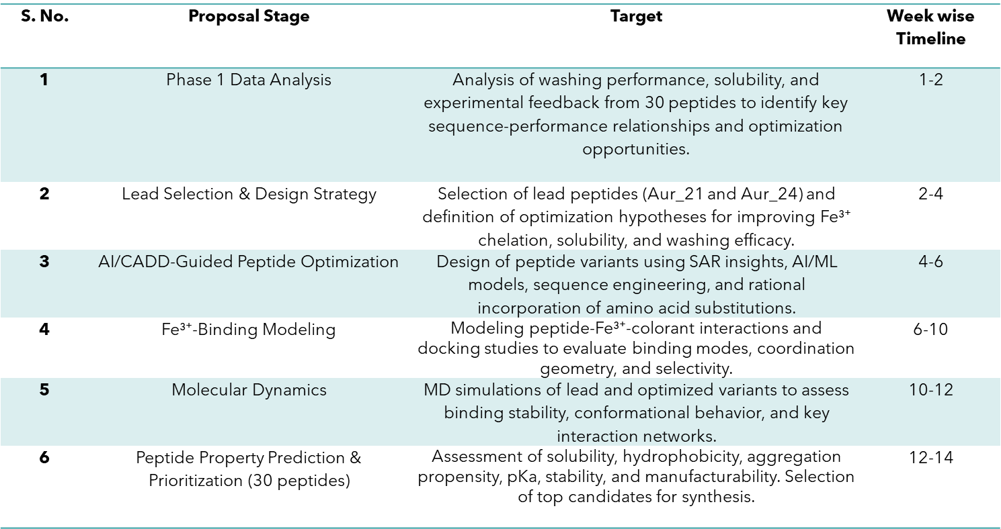

Target specification
Project 2: Phase 2 design
*All peptides are assumed to be 10-30 AA, natural L-amino acid and linear peptides. Unnatural amino acid (UAA) synthesis or procurement is not part of the scope and same will be billed as pass through to Henkel. If the complexity of peptide with UAA increases, price and timeline of peptides will vary.

Price and timeline
Project 2: Phase 2
Deliverable | Price (USD) | Timeline (Weeks)
Activity-1: Mid project report with list of 30 potential peptide candidates | ??? | 12-14 weeks

Assumptions
- All target compounds are expected to be stable during synthesis and purification. In case of a challenge arises, both parties will discuss and align on the way forward.
- The delivery timeline excludes the lead time required for raw material procurement from receipt of a purchase order.
- Duty and clearance charges for chemicals shipped by Henkel, if any, will be charged based on actuals as pass-through costs.
- Aurigene shall issue analytical results in the certificate of analysis.

Terms and Conditions
Payment Terms: Project 2
All payments pursuant to this engagement shall be made by wire transfer to bank account designated by Aurigene Pharmaceutical Services Ltd.
- For all Invoice: Immediate on receipt of invoice

Payment schedule
Milestone | % Project value
Completion of activity 1 | 100% of project value (non-refundable)

Quote
- All target compounds are expected to be stable during synthesis and purification. In case of a challenge arises, both parties will discuss and align on the way forward.
- Price estimates include the cost of a one-time, room temperature shipment to a single location advised by the client before the shipment initiation (Incoterms 2020: DAP). Any additional shipments or special shipments (ex., dry-ice shipments), if needed, during the project will be billed at actuals.
- All pass-through costs will have an administrative fee of 15%.
- In case any withholding taxes become applicable at the time of payment, then the total amount payable to the Service Provider shall be grossed up so that, in any event, the aggregate amount receivable by the Service Provider under this Agreement is not affected.

Intellectual Property
- Aurigene will ensure that Intellectual Property generated during the term of this project shall be transferred to client and client will exclusively own all data generated for the project(s).
- Aurigene recognizes the value of Intellectual Property for the collaborators and takes necessary measures to secure the same in addition to measures taken in information flow and data management

Scope Management
Should any out-of-scope activities arise during execution, the details shall be discussed between Aurigene and Henkel to amend the current scope and fees of the proposal.

Validity
This proposal is valid for 30 days from the date of submission.

Authorization
Each party’s signature on this document constitutes acceptance of the price, schedules, payment terms and other conditions set out or referred to in this quotation.

Henkel AG & Co. KGaA | Aurigene Pharmaceutical Services Ltd.
By | By
Name | Name
Title | Title
Date | Date

